Introduction to the Special Issue:
Collective Vigilantism in Global Comparative Perspective

Dara Kay Cohen, Danielle Jung, and Michael Weintraub

Forthcoming, Comparative Politics

Many in the US were outraged to learn of the February 2020 murder of Ahmaud Arbery, a twenty-five-year-old unarmed Black man, who was stalked and then shot to death by three white men, who claimed—without evidence—that Arbery was the suspect in a series of local robberies. Arbery was shot three times, and the incident was captured on video, which later garnered national attention. The spring of 2020 was also characterized by violent attacks against Asians in the UK and the US, including group beatings, knife attacks, chemical attacks, and pushing victims into traffic, in supposed retribution for the spread of the COVID-19 virus, believed to have originated in China. Examples of similar violence from other countries in recent years include the killing of suspected beef traffickers in incidents of “cow vigilantism” in India, and a spate of anti-Muslim mobs in Sri Lanka, fueled by social media rumors regarding an imagined Muslim plot to sterilize Sinhalese. Such incidents, in which ordinary citizens collectively enact lethal (or potentially lethal) retributions in the name of regulating local crime and offenses to the community, are all examples of collective vigilantism, which we define as group violence to punish perceived offenses to a community, and which is a persistent practice in many regions of the contemporary world.
Collective vigilantism is an accepted—and broadly publicly supported—response to real and imagined transgressions in many communities. Up to 30% of respondents expressed support for “citizen-led justice” in public opinion surveys in Mexico. Another study found even higher rates of support in a survey conducted in Khayelitsha Township, South Africa, where 75% of respondents reported that it is appropriate to lynch a murderer and 63% reported that it is appropriate to lynch a thief. Similar questions posed in Port-au-Prince Haiti found that 44% approved of lynching for murder and 49% for thieves. Acts of collective vigilantism have been featured in headlines in major newspapers, with journalists sometimes noting local incidents are not isolated events but rather part of a broader global trend. Although scholars in a variety of social science disciplines—especially anthropology, history, and sociology—have examined contemporary forms of collective vigilantism, the topic is nonetheless understudied. This is in part because social science disciplines tend to be siloed, but also because the subdisciplines of political science can make it challenging to develop a comprehensive global understanding of the issue: scholars of comparative politics may approach vigilantism as an issue of state authority, scholars of international relations may view it as an issue of political violence, and scholars of American politics may focus exclusively on the US historical case. In this special issue, we seek to break down these disciplinary and subfield barriers to build a more comprehensive study of these issues from a global and comparative perspective.
In this special issue of Comparative Politics we bring together a diverse set of scholars to examine the dynamics of collective vigilantism around the world. Although we do not claim to present a comprehensive global survey of the phenomenon, the articles focus on cases from countries across several regions–Southern Africa, North America, Latin America and Southeast Asia–and include detailed studies of Indonesia, Mexico, South Africa, Tanzania, Uganda, and the United States. While most of the articles focus on the contemporary period, [Paper 8] considers a longer temporal span, starting in the 1930s. The special issue also features a wide range of sources of evidence and research methods.
Much of the existing research on collective vigilantism in political science examines why individuals and groups engage in such violence in a particular context or country; however, a focus on motivations offers a relatively limited view on the practice. Instead, the articles in this special issue widen the scope of questions scholars ask about the causes, dynamics, and consequences of collective vigilantism. Together, they examine collective vigilantism both as independent and dependent variables. Questions include not only an exploration of the conditions under which people engage in collective vigilantism, but also why they support it (or not); why it takes different forms in different contexts and environments; and its consequences and legacies, including its effects on crime, the state, and broader society. Many of the scholars also offer insights into how best to study collective vigilantism, a sensitive and potentially divisive topic, and explore the implications of what their research suggests about how collective vigilantism can be mitigated or prevented.
Scholarly attention to collective vigilantism is not a niche concern. Rather, these forms of violence speak to abiding debates in the study of comparative politics. A more complete conceptualization of collective vigilantism will not only expand our understanding of contentious politics but also help to illuminate how we understand power and state authority. In addition, conceptions of political violence have extended beyond civil and interstate wars and state repression to include “intercommunal violence,” perpetrated by ordinary civilians against civilian targets, outside the context of a formal conflict. In terms of victim counts and the number of people affected, collective vigilantism may exceed many forms of mass violence more commonly studied by political scientists, and in some contexts may comprise a large share of interpersonal violence. Expanding the scope of types of political violence shifts scholarly attention away from violence that occurs exclusively when individuals or groups square off against state authorities, and towards violence that occurs when individuals confront their fellow citizens to settle disputes that implicate broader political, social, or economic disagreements or cleavages.
The practice of collective vigilantism also reveals how state (and non-state) authority is made, maintained, or challenged. In the case of the US, lynching lays bare the dynamics of racial violence and state formation. In other countries, and as demonstrated by the articles in this special issue, vigilantism exposes what people violently demand from the law. Other articles point to the destructive legacies of vigilantism, both for individuals and communities, as well as for the state. Taken together, these studies show why the broader problem of collective vigilantism is critical to understand, over and beyond the specific conditions under which it occurs. The long-lasting legacies of lynching and vigilante violence for national politics are demonstrated by the fact that journalist Ida B. Wells received a Pulitzer Prize in 2020, nearly a century after her “outstanding and courageous reporting” of the lynching of Black men in the American South; Wells’ research and anti-lynching advocacy efforts are also described in [Paper 8].
Despite the rising awareness of the practice’s importance for our understanding of state formation, the rule of law, and political violence, many questions about the causes, dynamics, and consequences of vigilantism remain outstanding. Taken together, the articles in the special issue address puzzles existing research has overlooked, and elucidate several cross-cutting themes that suggest fruitful paths forward for future research. In broadening the questions we ask about collective vigilantism, the articles in the issue illustrate how a wide variety of creative sources and methods can be leveraged to answer these questions, including including original surveys and survey experiments; event data; archival evidence, such as case files from civil rights organizations and government agencies; and detailed case studies and interviews based in immersive fieldwork. These methods and data uncover new patterns, even in well-studied cases. Increased interest in collective vigilantism presents an exciting opportunity to set the agenda for the next wave of research on these topics, informed by political science theories and methods, and situated within a global and contemporary perspective.
In addition, the data on collective vigilantism globally reveal distinct answers—and explore the conditions under which these answers matter—about the causes, dynamics, and consequences of lynching and vigilantism. One pair of authors in the special issue, for example, examine the same case and the same body of evidence, but focus on divergent scope conditions, ultimately suggesting distinct and complementary theories of collective vigilantism. These two articles both use the World Bank’s National Violence Monitoring System (NVMS) database to examine collective vigilantism in Indonesia. The authors of these papers, however, arrive at different conclusions about the causal dynamics of vigilantism, with one set of authors focusing on the period of extraordinary flux in post-tsunami Aceh, marked by the retreat of the military and a sharp increase in religiosity—and the other analyzing how the practice in more ordinary times, and over a longer timespan, has been associated with the gradual growth of the state throughout Indonesia. This special issue is the first of its type in political science, bringing together a set of accomplished and emerging scholars of comparative politics, international relations, and political violence, each with fascinating examinations of collective vigilantism. The special issue represents a collective effort at a crucial moment to frame, connect, and collaborate on an emerging literature in political science. Given that collective vigilantism sits at the intersection of several perennially important political issues for scholars, this collection will be of interest to researchers of contentious politics, political violence, development, state capacity, crime, inequality, and race and ethnicity.
Beyond the specific questions about collective vigilantism that emerge from various subdisciplines, we outline what a general political science treatment of collective vigilantism ought to address. A political science treatment of collective vigilantism should, in our view, seek to understand four interrelated aspects of the practice: (1) whether it undermines or reifies state authority; (2) whether it improves or erodes security conditions, and for whom; (3) whether it creates new social, economic, and/or ethnic divisions through acts of vigilante violence, and/or exacerbates existing ones; and (4) whether it has long-term political social consequences, and an exploration of what these are. In other words, political scientists ought to understand vigilantism’s immediate and long-term effects on the state, including its implications for security conditions and social cleavages, and how those cleavages are defined. Political scientists should also pay close attention to how this practice may contribute to meaning-making and identity creation along social, economic, and ethnic cleavages. This special issue highlights that questions of authority--central to political science--and the multiple methods used to study authority within comparative politics, have much to offer to the study of collective vigilantism.
Definitions and Terminology
While there are many definitions of vigilantism in the literature, this special issue focuses on “collective vigilantism,” for which there is no broadly accepted, universal definition. Research on the topic has been hampered by definitions that are “contradictory, tautological, and not easily operationalized.” This is made more challenging because disparate data sources often use their own unique definitions. For example, historically, individual newspapers and civil rights organizations employed different definitions and distinct terms (“lynching,” “posse,” and “mob” ) when reporting on lynching in the American South, making aggregation across sources challenging (as described in [Paper 8]). In the contemporary context, local populations often have their own terms for lethal collective vigilantism. Residents of Port-au-Prince use a variety of interchangeable terms that translate to lynching, community justice, and mob violence. Respondents in Sub-Saharan Africa call this violence “mob justice” ([Paper 2]). Finally, commonly-used terms shift over time, as displayed below in Figure 1. In United States State Department reporting on human rights practices, the term vigilantism was used exclusively to describe these acts in the late 1970s and early 1980s. However, while vigilantism remains the modal term, beginning in the mid-1980s and increasing through the early 2000s, terms like lynching, mob violence, and community justice became more common, peaking at about 40% of descriptions in the State Department reports.
Figure 1. Collective Vigilantism Terms in U.S. State Department Reports, 1979-2013
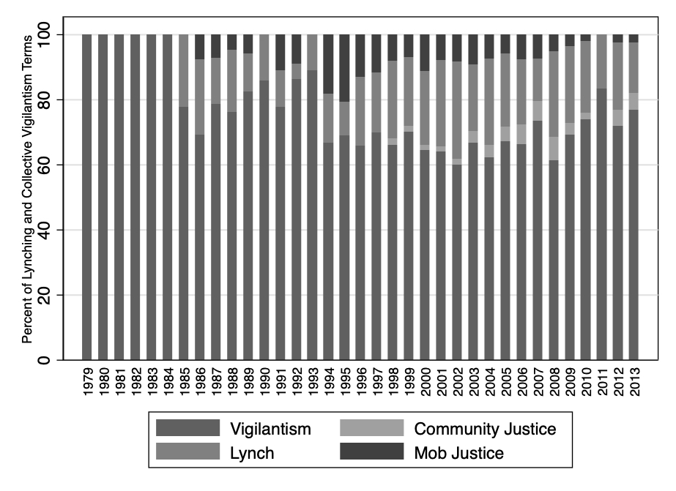
Source: Jung and Cohen (2020)

In the special issue, we define collective vigilantism as group violence to punish perceived offenses to the community.” These “offenses” can range from violence perpetrated against those thought to have committed violent crimes, such as rape, murder or robbery, to those accused of “moral offenses” (e.g., those engaging in premarital dating or sex); violence committed against those perceived to be outsiders to the community (e.g., members of the LGBTQ+ community); or violence against individuals defying cultural norms (e.g., men with long hair). Each set of authors has anchored their analysis on this foundational definition, and has addressed how their own conception of collective vigilantism fits into the typology (e.g., Paper 2 studies spontaneous collective vigilaiantism in several African countries) or how it differs; for instance, the authors of [Paper 4] prefer to use the term lynching for their examination of vigilante violence in Aceh.
Finally, the forms of collective vigilantism explored in the special issue are nearly all public, performative acts of group violence. Central to understanding this violence is the notion of “violent display,” the result of the pathbreaking work of political scientist Lee Ann Fujii, who defines it as “the collective effort to stage violence for people to…experience first-hand.” At the time when she passed away suddenly in 2018, Fujii was completing a book manuscript, published posthumously in 2021 by Cornell University Press, that analyzed and compared public displays of violence during the Rwandan genocide, the Bosnian war, and a lynching in the US state of Maryland. The former two cases are periods of extraordinary, conflict-related violence; in this issue, as in Fujii’s third case, we shift the focus to the ordinary violence of the everyday. This collection of essays is indebted to Fujii’s pioneering insights on this topic.

Typology of Collective Vigilantism
Having defined collective vigilantism, we now consider the ways that individuals and groups “take justice into their own hands” for a variety of reasons, and under distinct conditions. Acts of collective vigilantism are pervasive across time and space. Some can be considered anti-status quo, while others are status quo-preserving. Some appear to be committed by groups with durable organizational structures, while others are committed by loose collections of individuals that “disappear” once acts of vigilantism have been committed. Some acts of collective vigilantism are committed in the context of persistent insecurity and state retreat, where the state is unable or unwilling to provide guarantees of life and property. Others occur to support law enforcement and policing, with organizational vehicles that become extensions of state authority.
The civil war and post-civil war context is particularly prone to the creation of vigilante and vigilante-adjacent groups; by one estimate, 75% of all civil wars since the end of the Cold War have involved militias or paramilitaries. In some cases, governments have actively and forcibly mobilized such groups to counter threats to the regime. At one extreme sits the Guatemalan government’s mobilization of nearly one million men to staff look-out posts, patrol, and serve as logistical auxiliaries when the military conducted raids against insurgents in the 1980s. At the other extreme sit the autonomous armed self-defense groups formed by tribal elders in the four most southern states of what is now South Sudan. Somewhere in the middle are cases like Sierra Leone, where the Donso, Tamaboro, and the Kamajor militias were primarily formed locally, but with the encouragement of the National Provisional Ruling Council, the country’s military junta. In Peru, both autonomous bottom-up mobilization and compulsory top-down organizing of the rondas campesinas occurred at different moments of time and across space.
To create a comprehensive framework for studying these disparate phenomena, we present a two-by-two typology of collective vigilantism, displayed in Table 1. The typology displays both historical and contemporary examples of collective vigilantism, and shows where the acts described in each of the articles in the special issue sits relative to the others.

Table 1. Typology of Collective Vigilantism
 |  | Extent of Organization
 |  | Spontaneous Organization | Durable Organization
Aim | Enforce Social Order | Lynching in post-tsunami Aceh [Paper 4]  Unplanned hate crime attacks (e.g., murder of Matthew Shepard in the US)  Attacks on Asians in US and UK during the COVID-19 pandemic | Anti-Black lynching in US [Paper 8]  Autodefensas Unidas de Colombia (Colombia)  Civil patrols (Guatemala)  Occupy Pedophilia (Russia)
 | Reduce Crime | “Mob vigilantism” in Southern Africa [Paper 2]  "Decentralized collective vigilantism" in the Mexican berry sector [Paper 5]  Vigilantism in Indonesia [Paper 3] (when targets are community outsiders)  Citizens punishing thieves in Port-au-Prince (Jung and Cohen 2021) | Community patrols, armed neighborhood watch groups  “Centralized collective vigilantism” in the Mexican avocado sector [Paper 5]  Vigilantism in Indonesia [Paper 3] (when targets are community insiders)  Brigades in Haiti  State-sponsored crime prevention panels in Uganda

We distinguish collective vigilantism on the basis of the extent of organization of these acts and their aims. While a continuum exists for both axes, it is useful to think of an ideal-typical two-by-two. We begin with the extent of organization. “Spontaneous” acts of collective vigilantism are committed by those not bound by an organization with a name or clearly-codified rules governing membership; are typically ordinary citizens; and mobilize in an ad hoc, improvised fashion, typically in response to temporally and geographically-defined events. In contrast, durable organizations have a name, a stated purpose with more-or-less clearly identified goals (frequently enshrined in a constitution or founding document), and oftentimes feature rituals or rules to “even out” or police the behavior of members.
The other factor across which collective vigilantism varies concerns its aims. Some vigilantes are formed and maintained to enforce social orders, which involves the mobilization of private citizens to eliminate those perceived to be of a different social, economic, or political group, while other acts of vigilantism seek to reduce common or organized crime.
As Table 1 shows, those perpetrating collective vigilantism in a spontaneous way to enforce social order include the acts of vigilantism seen in [Paper 4] in post-tsunami Aceh, Indonesia; hate crimes committed by friends or acquaintances, as was the case of the torture and murder of Matthew Shepard in Laramie, Wyoming by Aaron McKinney and Russell Henderson in 1998, after meeting in a bar; and attacks against Asian-Americans in the United States in the early phases of the Covid-19 pandemic. As argued in [Paper 2], spontaneously formed mobs of ordinary citizens often disproportionately focus on racial or ethnic targets due to easier coordination among perpetrators. Those interested in enforcing social order under the umbrella of a durable organizational structure includes lynchings in the American South, as discussed in [Paper 8]; the Autodefensas Unidas de Colombia that mobilized ordinary citizens to fight against left-wing insurgents and “cleanse” (limpiar) the population of “undesirable” groups such as homosexuals, drug addicts, and the mentally disabled; Occupy Pedophilia, a Russian anti-LGBTQ+ group, which largely targetted gay men and posted their attacks online; and civil patrols in post-civil war Guatemala.
Among vigilantes aimed at reducing crime, spontaneously organized civilians that use violence to punish a thief sit in the lower left-hand box of Table 1. [Paper 3] describes how this takes shape in the Indonesian context, where a group of civilians might interrogate an accused thief before calling in others to participate in a retributive attack on the accused; the entire process takes between 2-5 hours. [Paper 5] describes how "decentralized collective vigilantism" in the Mexican berry sector was characterized by competing groups of victims, in ways that involved autonomous mobilization from the state and that left them vulnerable to criminal capture.
Community patrols or neighborhood watch organizations sit in the lower right-hand quadrant of the table. Examples include neighborhood brigades in Haiti, groups of civilians loosely trained and supported by local police to prevent, investigate and punish crime, and state-sponsored crime prevention panels in Uganda. As [the author of Paper 3] found, organized collective vigilantism in Indonesia is most common when the target of a lynching is an outsider, and the accusations of wrongdoing (e.g., sexual indiscretion or sorcery) are typically long-standing—sometimes for years. A new violation typically triggers a process of deliberation about violent punishment, which can be highly contentious in the community, and can take weeks. Efforts at social control can be cast by vigilantes as crime prevention to serve their own purposes as well; the “aim” of the violence may be in the eye of the beholder.
Vigilantes that have durable organizational structures may be more likely to have lasting impacts on the beliefs and behaviors of communities. A broad literature shows that formal institutions produce organizational legacies that are not easily unwound, and that these are especially acute during and following periods of violence, when identities become hardened and populations polarized. Collective vigilantism perpetrated by groups with durable structures may be more successful at producing sustained incidents of violence that polarize communities, eroding trust in both state institutions and among ordinary citizens, thereby leading to lasting legacies of instability.
Yet acts of collective vigilantism by spontaneous groups may also produce persistent changes in attitudes and behaviors, especially if they increase inter-group polarization. As social psychologists Littman and Paluck write, “engaging in violent behavior increases identification with one's violent group, leading to a cycle of violence in which group identification increases willingness to engage in violent behavior and perpetrating violence increases group identification.” Scholars of terrorism and political violence have likewise found that terror attacks induce “groupish” behavior, hardening support for identity-based security policies. In the case of highly public collective vigilantism—embodied in the lynch mob, but not unique to it—even those on the sidelines are strongly affected by the within-group cohesion and inter-group hatred that collective violence produces. These in-group/out-group dynamics may harden existing identities, reinforcing cleavages and mistrust that likely persist over time.

Global Patterns of Collective Vigilantism
Collective vigilantism, in its various forms, is a commonplace and global phenomenon. Figure 2 displays all the countries where forms of collective vigilantism were reported in the State Department reports between 1979-2013; forms of collective vigilantism were reported in 102 countries, in all regions of the world. These data show that collective vigilantism is very widespread—in fact, there are reports of collective vigilantism in the majority of states, suggesting a vast global prevalence of these practices.
Collective vigilantism is not limited to the poorest states and can emerge in a variety of governance settings, not merely in weak, low-capacity, or poorly governed states. As Jung and Cohen (2020) show, while the top quartile of countries by income are least likely to have had reports of collective vigilantism, there is little difference in frequency of reports among the three lowest quartiles of states by income.

Figure 2. Global Prevalence of Collective Vigilantism, 1979-2013
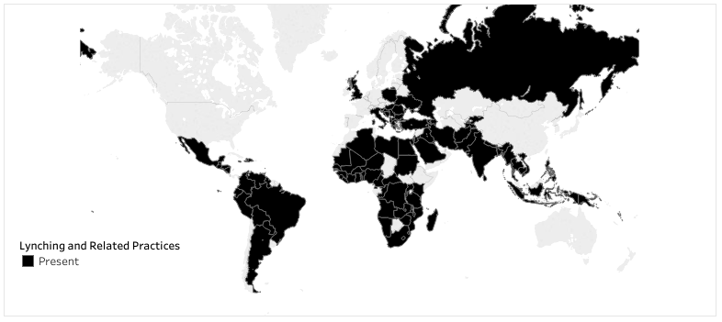
Source: Jung and Cohen (2020)

The source documents also show significant diversity in reported methods used to perpetrate collective vigilantism. By far the most common method is beating, followed closely by burning. Other methods, such as stoning, shooting, hacking, and hanging, are less common. There may also be forms of violence that are particular to a time and place, and the form itself can sometimes be symbolic. Of particular note is the relatively low incidence of hanging in the contemporary global context, while it was a dominant method in anti-Black lynchings in the United States. As Gutierrez-Sanín and Wood note in their work on patterns of violence, it is crucial not only to distinguish between repertoires of violence -- the subset of forms of violence regularly deployed -- but also who is attacked, how it is done, and how frequently.
This brief examination of global patterns demonstrates the failure of conventional wisdom regarding the causes of collective vigilantism. For instance, a common narrative dictates that collective vigilantism is the exclusive purview of poor countries or weakly institutionalized states. The cross-national snapshot above challenges that assumption. As the authors of [Paper 4] argue, contemporary incidents of collective vigilantism may be “concentrated in countries with imperfect democracies…where the state may be strong enough to manage the threat of large scale collective violence, but not legitimate enough to prevent less organized forms of extralegal justice.” The cross-national data shows that collective vigilantism does not always take a particular form, is not confined to a specific time period, and is not associated only with particular cultures and beliefs. Together, they highlight the need for theorizing and detailed micro-level data to analyze the causes, dynamics, and consequences from a comparative perspective, a gap that the papers in the special issue begin to fill.

Latin American Attitudes Towards Vigilantism: The Promise of Micro-Level Data
To demonstrate the promise of micro-level data, we examine public attitudes towards the appropriateness of collective vigilantism using the 2014 Latin American Public Opinion Project (LAPOP) data from all 28 countries for which data are available. The core question of interest is support for citizens taking matters into their own hands when the state does not punish criminals. We consider this a lower bound on support for collective vigilantism, given that the question itself makes clear that justice was not done, when a crime had in fact been committed.
We find that support for vigilantism among the approximately 50,000 respondents is surprisingly rather limited: 74% express either strong or moderate disapproval of vigilantism (1-5 on a 10 point scale), while only 26% express moderate or strong approval (6-10 on a 10 point scale). As may be expected, support for vigilantism is more pronounced in some of the region’s most violent countries—Haiti, Honduras, and El Salvador, for example, see more moderate to strong approval for vigilantism (6-10 on a 10 point scale). There are exceptions to this pattern, however: Venezuelans display more strong to moderate disapproval (1-5 on a 10 point scale). We find that respondents living in the most prosperous countries in the sample tend to be slightly less supportive of vigilantism: disapproval of vigilantism (again, 1-5 on a 10 point scale) in Canada reaches 73%; in the United States, 76%; in Uruguay, 78%; and in Chile, 81%.
What factors are correlated with support for vigilantism? While establishing causal relationships is beyond the scope of this exercise, we identify a suggestive relationship between support for collective vigilantism and a belief that the courts do not punish those responsible for committing crimes. Controlling for individual characteristics such as gender and age, and including country and urban/rural area fixed effects to account for unmeasured heterogeneity between individuals, we find that skepticism towards the justice system is positively correlated with support for vigilantism. Those who report the lowest level of confidence in the justice system are 14% more likely to support collective vigilantism when compared to those who report the highest level of confidence in the justice system (see Figure 3 below).
Figure 3. Lack of confidence in the justice system
increases support for collective vigilantism
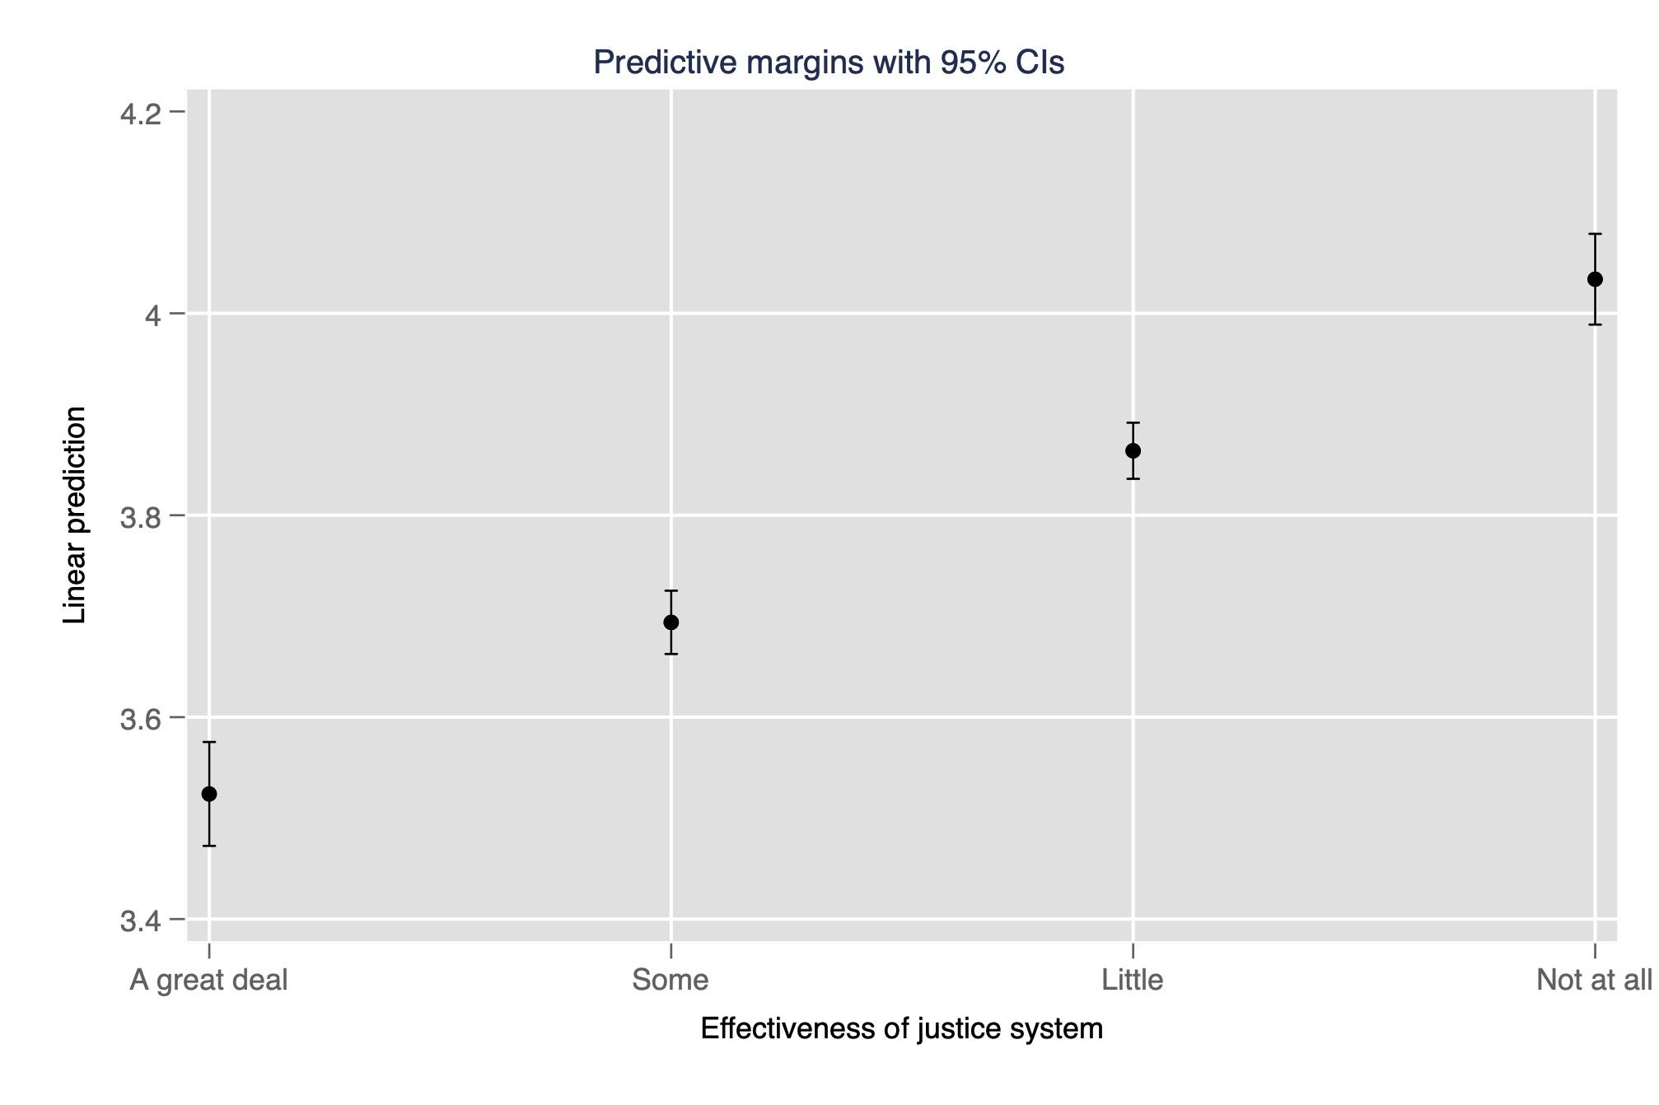
Negative perceptions of personal safety are also associated with support for collective vigilantism. After controlling for confounders, we find that respondents who view their neighborhoods as “very unsafe” are 13% more likely to endorse vigilantism, when compared to those who view their neighborhoods as “very safe.”

Figure 4. Perceptions of safety are negatively correlated
with support for collective vigilantism
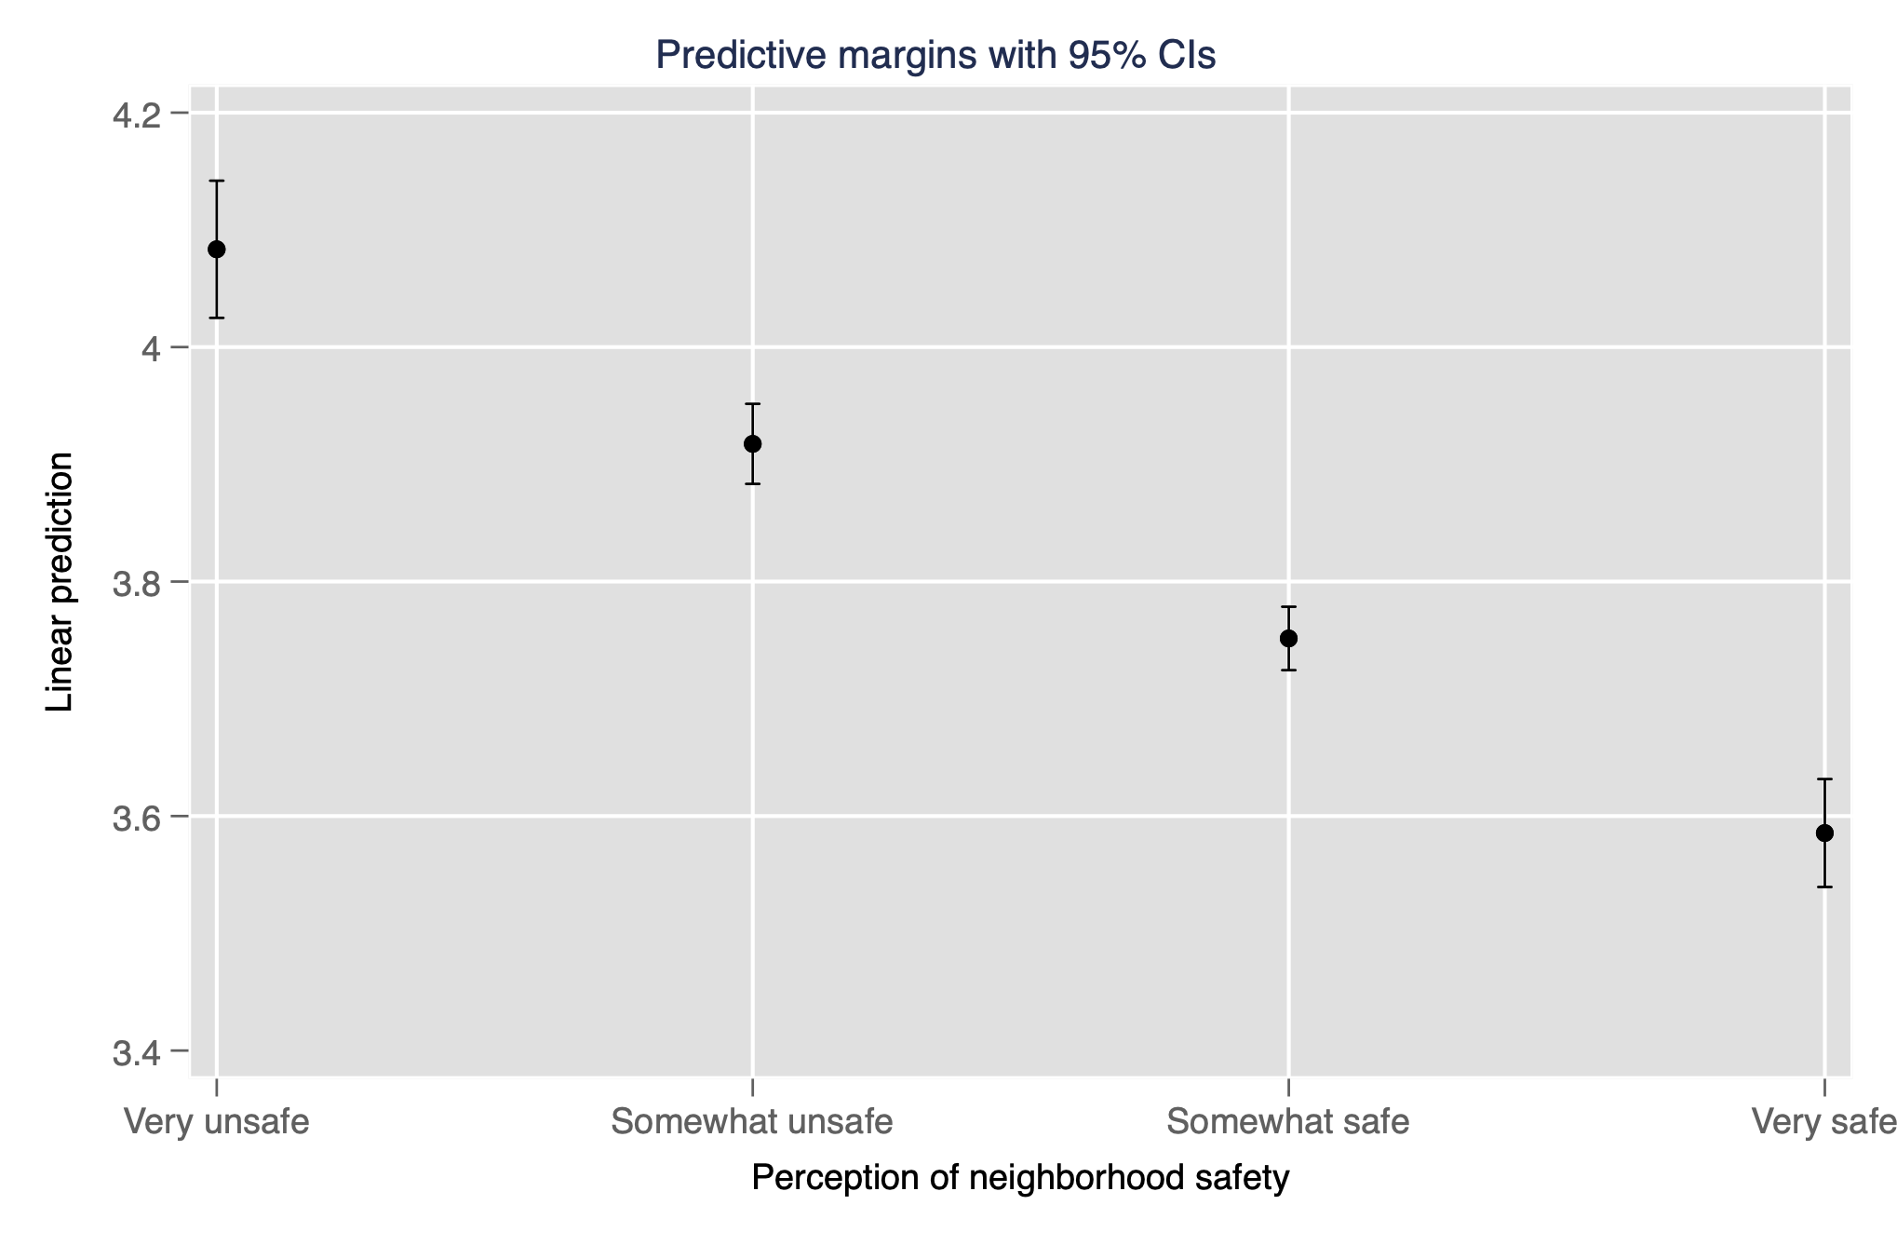
We also find that direct, recent victims of crime (in the prior 12 months) are, on average, 9% more supportive of vigilantism than non-victims. (This is a lower-bound on the identified effect, given that those who were victimized prior to the 12-month period included in the question would be counted as non-victims.) Finally, support for vigilantism is correlated with perceptions of police efficacy. Again controlling for the aforementioned factors, those who are dissatisfied with the police are 29% more likely to approve of collective vigilantism when compared to those who are “very satisfied” with the police.
Taken together, these statistical exercises not only offer a comparative perspective for the special issue, but present stylized facts about how governance failures can help explain variation in support for vigilantism.
Contributions to the special issue
The special issue includes four articles and a research note that touch on critical topics relating to state formation, contestation, crime, law and justice, inequality, and race and ethnicity. All demonstrate the value of a political science approach to the study of collective vigilantism.
The first paper in the special issue, [Paper 3], touches on issues of who makes claims on the state, as well as broader concerns of how insecurity at the local level shapes the practice of collective vigilantism. In the context of the functioning Indonesian state, [Paper 3] presents a theory of “selective impunity,” in which collective vigilantism emerges as the result of a bargain between citizens and street-level bureaucrats. In particular, police tolerate, grant impunity and even offer protection to vigilantes who respond to crime, traffic accidents, and to a lesser extent, moral offenses—but only until the point where vigilantism risks sparking large-scale communal violence. Under conditions of limited resources, subcontracting vigilantism for local infractions to citizens allows police to focus more attention on national-level security threats: ethnic violence and terrorism. The use of vigilantism in the presence of police allows for communities and police to converge on a mutually accepted sense of where the boundaries of the practice are, and for police to subsequently offer protection to perpetrators, preventing acts of retribution by vigilante victims. [Paper 3]’s multimethod contribution draws on extensive fieldwork, including interviews with perpetrators and police, and uses the World Bank’s National Violence Monitoring Service data for details on vigilantism across the country, as well as 20 qualitative case studies to investigate the implicit negotiation between the police and communities over collective vigilantism.
[Paper 4] focuses on how collective vigilantism is a response to collective threat in the wake of natural disaster and state failure. In addition to highlighting security concerns at a moment of extreme social and political uncertainty, [Paper 4] also illuminates how collective vigilantism both results from and serves to deepen social cleavages; in this case, showing how religious cleavages and related gender-based anxieties about sexual purity serve as motivations for collective vigilantism. The authors examine the conditions under which collective vigilantism is most likely to emerge, arguing that two conditions make lynching more likely: a shared sense of moral offense due to a collective threat, and a weakened state unable or to unwilling to provide justice. While each condition creates opportunities for increased lynching, their primary dependent variable, the authors argue they are hard to separate empirically and ought to be studied together. The authors leverage the shock of the devastating impact of the 2004 tsunami in Indonesia, and argue that the tsunami in Aceh resulted in a period of extraordinary “flux,” which met both conditions: many Indonesians believed that the tsunami was divine punishment and the aftermath of the tsunami dramatically reduced the state’s military capacity, conceptualized as the state’s ability to enforce compliance with rules and its legitimacy to enforce that compliance. While the disaster brought the civil war in Aceh to a quick conclusion, the subsequent peace agreement disarmed the rebel group, which had previously managed local-level disputes. The agreement also decreased the number of police in Aceh, and as police shifted tactics, this produced a greater tolerance for low-level crime, thereby weakening state security forces.
The authors explore the observable implications of their argument from multiple levels of analysis and exploit variation across both space and time. They focus on variation within Aceh, where the shocks to policing and religion were likely to be greatest. Using data from the National Violence Monitoring Service (a dataset couthored by [Author of Paper 3]—and also used by—[Paper 3], in this issue), [Paper 4] finds support for the argument: post-tsunami lynchings skyrocketed in Aceh to nearly six times pre-tsunami levels, but stayed relatively constant on average across other regions of Indonesia. Their within-Aceh analysis shows that lynchings were more likely to occur in areas previously controlled by the rebels—those areas with weakest policing—and in regions with the greatest share of Islamic buildings, which they argue are areas with higher “morality,” or a greater shared sense of right and wrong. Finally, lynchings for “moral crimes,” premarital sexual contact in particular, dramatically increased, even though crime decreased overall.
To better understand the drivers of collective vigilantism, our issue also turns an eye to public support for the practice. Understanding who supports collective vigilantism can shed light on motivations and offer insights into how to curb the violence. [Paper 2] calls attention to some of the critical dynamics that underpin support for vigilantism; in this case, [Paper 2] centers on social cleaveages that pertain to sex and gender differnces in how collective vigilantism takes shape.
The author of [Paper 2] uses qualitative, experimental, and survey data from three sub-Saharan countries, Uganda, Tanzania, and South Africa, to show a persistent gender gap in support for vigilantism: across these three states, women are consistently more supportive—as much as two times more supportive—than are men. This is particularly surprising given that a large body of public opinion literature demonstrates that women tend to be less supportive of violence and the use of force in other security domains. [Paper 2 author] theorizes why this might be the case, arguing that the gender gap is driven by differential beliefs about the likelihood of punishment for a crime the respondent did not commit. [Paper 2 author] argues men are far more likely to be falsely accused of a crime that may lead to retributive violence, thereby increasing the costs of collective vigilantism for men and reducing their support.
[Paper 5] examines variation in vigilante resistance to criminal organizations, broadening the actors, beyond the state or other civilians, to which the practice is intended to respond. [Paper 5] also highlights another social cleavage implicated in collective vigilantism–economic cleavages– and offers political economy as an explanatory variable. [Paper 5]’s contribution offers a wider lens on collective vigilantism, examining potential sources of the form of collective vigilantism as a method of resistance to criminal victimization. When do we see collective vigilantism centrally coordinated in a single organization, versus a decentralized setting where multiple groups operate autonomously? [Paper 5]’s theory speaks explicitly to the role of the state and local authorities to understand collective vigilantism may look more or less centralized. [The author of Paper 5] shows how different state-business relations produce either an encompassed or segmented local political economy, which shapes organizational characteristics, as well as ties to the state. Variation in the local political economy in turn affects whether collective vigilantism is centralized or decentralized. Using interview and archival data from two municipalities in Michoacán, Mexico, [Paper 5] argues that the local political economies dictate the form that collective resistance takes because they shape the nature and ease of coordination and collective action. The framework opens up new questions in the scope and study of collective vigilantism, including specifying the conditions under which vigilantes are more or less likely be coopted by criminal groups or state authorities, with potentially devastating consequences for ordinary citizens.
The final contribution in the special issue turns to what is arguably the most widely-studied case of collective vigilantism —the US historical case of lynching. [Paper 8] analyzes state-society relationships in terms of authoritarian enclaves, focusing on politically- and socially-relevant cleavages of race. [Paper 8]’s research note describes the painstaking process of documenting collective vigilantism in the service of the creation of a major new dataset. The dataset includes, at the latest count, nearly a thousand confirmed cases of lynching that offers insights into the roots and consequences of collective vigilantism, and lessons for understanding the lasting legacies on contemporary anti-Black violence. Coauthored with [Paper 8’s project coauthor], the Director of the [Redacted] Project, the dataset focuses on racial killings in the 11 Confederate states, beginning in 1930 when the original Tolnay and Beck data end. This data and archival effort grapples directly with the role of the state discussed in other contributors’ work, specifically through tracing and documenting the active and passive role of law enforcement officers at racial killings. The labor-intensive process of building the database and archive involved gathering evidence from newspapers, police records, civil rights organizations’ files, and interviews with relatives to investigate each case. In addition to the hundreds of confirmed cases currently contained in the archive, [the author of Paper 8] has identified and is currently investigating numerous potential cases, as well as hundreds of cases of averted lynchings. These numbers are staggering; they suggest the scale of lynching in the US may be far worse, and its temporal scope far longer, than previously understood. The research note offers lessons for the broader study of collective vigilantism, both in terms of data collection and methods, while also providing important insights into how collective vigilantism contributed to the development of authoritarian enclaves and negatively affected democratic governance in the American South.

Cross-cutting themes
Studying the dynamics of collective vigilantism from a political science perspective highlights several themes in this special issue. In line with the political science approach to vigilantism that we outlined above, here we highlight how the contributions in the special issue address each dimension: whether collective vigilantism undermines or reifies state authority; the effect collective vigilantism has on security; whether (and how) collective vigilantism creates new social, economic and/or ethnic divisions and/or exacerbates existing ones; and whether collective vigilantism has long-term political and social consequences.
The first two cross-cutting themes center on the role of the state in collective vigilantism, and in particular how eroding or reifying state authority contributes to or weakens the provision of security for ordinary citizens. Core questions pertaining to the role of the state include, for example, whether vigilante violence serves as a substitute or a complement to state violence. Common explanations for vigilantism focus on state weakness, and the state’s lack of presence in a given context; a typical argument suggests that in the absence of police, ordinary citizens then take the law into their “own hands” to self-police their community. There is ample evidence to support this perspective: citizens do sometimes engage in vigilantism to fill the void where the state (and the police) ought to be. [Paper 4], for example, emphasizes weakened state authority in the aftermath of a natural disaster as one condition for widespread collective vigilantism.
However, state weakness is not and cannot be the whole story. As several recent studies make clear, state capacity is distinct from state legitimacy: police presence may be less important than whether the community trusts the police to investigate and manage crime. In the Haitian context, for example, collective vigilantism is more prevalent in areas with greater police presence. Similarly, in Indonesia, [Paper 3] finds that a greater presence of street-level police officers are associated with an increase in vigilante violence, against the backdrop of a gradual increase in the state’s “coercive presence.” Using the same dataset, [Paper 4] focuses on the crisis induced by the 2004 Indian Ocean tsunami in Aceh, and finds an increase in collective vigilantism when the state’s military authority declined; the divergent findings suggest distinct pathways in how collective vigilantism is produced, depending upon whether individuals find themselves in ordinary times, or in extraordinary periods of flux and uncertainty. The upshot is that state presence alone is insufficient to build legitimacy if the police and the broader justice system are mistrusted, as was suggested earlier using the LAPOP polling, or are in collusion with vigilantes, as in Indonesia ([Paper 3]).
Also relevant to the role of the state is whether the police and state security forces tolerate, enable, or even co-perpetrate acts of vigilante violence, regardless of whether security force officials participate in uniform or not. As [Paper 8] notes, “[g]overnace includes behavior of state actors,” and notes that police, sheriffs, and others in law enforcement in the American South co-perpetrated numerous lynchings, and failed to protect victims already in custody. Moreover, because Jim Crow laws and etiquette were often indistinguishable in practice, their violations were enforced similarly, with the effective force of law. As a result, [the author of Paper 8] includes violence by security forces in her definition of lynching. [Paper 3], in contrast, specifically excludes it, arguing that collective vigilantism is conceptually (if not always observationally) distinct from state repression, and should therefore be defined as forms of violence perpetrated by “private citizens,” or “ordinary” people ([Paper 3]: 13), rather than by those trained in the use of violence. This tension will be a fruitful area for future theorizing by political scientists.
A third cross-cutting theme concerns social cleavages that may be reinforced or undermined by collective vigilantism. Collective threats to a given community may be real: for example, the devastating tsunami in Aceh caused an acute shock to the state’s military authority ([Paper 4]), and rampant crime or persistent criminal violence likewise has prompted communities to take justice into their own hands ([Paper 2]; [Paper 5]). At the same time, however, collective vigilantism may occur in response to imagined threats posed by an out-group to an in-group [Paper 8], especially during periods of social or institutional flux, as described in [Paper 4]. Identifying and understanding the interrelated social, political and economic cleavages along which mobilization occurs against collective threats–real or imagined–is crucial to political science treatments of collective vigilantism. Comparative politics is particularly well-suited to undertake this task: the literatures on ethnic and racial politics, inequality, and discrimination against migrants, for example, can all provide insights into the causes and consequences of mobilization against collective threats, and might provide clues as to how best to explain variation in attitudes towards, or even participation in, acts of collective vigilantism.
Another cross-cutting theme concerns the role of sex and gender in shaping motivations and narratives about collective vigilantism. [Paper 2] deals most directly with this issue, focusing on the gendered perceptions of risk and threat that drive a substantial sex gap in support for vigilantism. Sex and gender play subtler but still central roles in several other papers in the special issue. [The authors of Paper 4] show an increase in lynchings in Aceh was partially in response to khalwat, pre-marital interactions between opposite-sex couples, suggesting that anxiety over women’s sexual purity is at the core of this violence. [Paper 2] also note women’s pivotal roles in sparking incidents of vigilantism through accusations of crime: two of the experiments focus on crimes against women, including the death of a girl and marketplace theft. Research shows that the “innocence” of a victim is a critical factor in shaping preferences for harsh punishment.
Given that “innocence” itself is often gendered, “protecting women” may be an understudied driver and justification for vigilantism. Data from lynchings in the American South appears to bear this out: accusations of rape of white women by Black men were a common trigger for lynchings and were often used as a rhetorical weapon. According to Ida B. Wells’ analysis, about 30% of lynchings were perpetrated to punish alleged raped. The new data presented in [Paper 8] can be used to trace how these allegations changed over time.
Finally, while the majority of papers in this issue study contemporary phenomena, making it difficult to assess the long-term consequences of collective vigilantism in their respective cases, several papers suggest that the attitudinal and behavior changes that vigilantism induces, or that cause vigilantism, might have durable consequences. [Paper 2], for example, argues that differing beliefs between men and women about collective vigilantism can be traced to assessments of personal risk of being falsely accused of a crime. One potential mechanism is intergenerational transmission of beliefs: “[t]he views of parents are also particularly likely to shape how mob vigilantism is viewed by younger generations,” which indicates that gendered support for collective vigilantism may be self-perpetuating via familial transmission.
[Paper 4] shows that impunity for vigilantism takes on an “iterated game” dynamic in which there must exist a long-term expectation of returns to street-level police for protecting vigilantes. One implication of [Paper 4]’s analysis is that over the medium- or long-term this selective impunity related to vigilantism may extend to crime fighting more broadly, eroding security for residents who initially applauded and collaborated with vigilantism. [Paper 5] likewise invites examinations of the long-term consequences of the phenomenon under study. While centralized collective vigilantism in the encompassing political economy in the avocado sector produced violence against criminal actors, the Mexican case studies prompts a consideration of how resilient these groups will be over the long-term: will they fall victim to attempts at cooptation from criminal groups or the state, as was the case with self-defense forces in Guerrero and Michoacán during surges in criminal violence? [Paper 4] shows how a shared morality based on salient collective threats provokes collective vigilantism, it remains to be studied whether the “immediate shift towards moral improvement” that the tsunami occasioned, and the attendant increase in collective vigilantism experienced in Aceh, deepened religious cleavages in ways that might have outlasted the events themselves. At the same time, if vigilantism was perpetrated in part to deter pre-marital interactions between opposite-sex couples, this violence may over the long-term successfully reinforce pre-existing but not necessarily dominant traditional gender norms.

Conclusion and implications for policy
This special issue is meant to begin a disciplinary conversation that acknowledges the expansive global reach of the phenomenon of collective vigilantism. But it is neither the final word on the scale of the issues, nor is it meant to dictate how these phenomena ought to be studied. Rather we have sought to show the potential for a productive research agenda with a true comparative spirit, showcasing the wide variety of methods and sources that can be creatively leveraged to study questions of the causes, dynamics and consequences of collective vigilantism, and to address new questions that may emerge. A robust research agenda moving forward will require continued advances in theory and further innovative efforts at data collection.
This special issue also invites a reflection on how related yet distinct phenomena, especially those that have been studied more deeply by political scientists, differ from collective vigilantism, and might inform the latter’s study. The study of political violence, for example, has included analyses of militia formation, rebel group formation, terrorism, and even violent state-building. Building on this work suggests a wide range of questions for future research. For example, do organized and spontaneous vigilante groups attempt to screen perpetrators and participants in collective vigilantism, as sometimes occurs in rebel groups? Do organized vigilante groups take measures to discipline members of mobs if they step outside of the boundaries of expected behavior, as frequently occurs in both rebel groups and gangs? How, precisely, does victim selection occur? Are victims selected to maximize shock value to the victimized community and/or to maximize publicity, as often occurs with terrorism, or is target selection based on another set of criteria? Have social media advances–which have altered protest tactics and state repression tactics, for example–also had an influence on vigilante tactics? Under what conditions do state authorities collude with or help “stand up” vigilantes? Might the literatures on state sponsorship of terrorism, proxy wars, or even cooptation of the state by organized crime help shed light on this and related questions? Applying insights from related phenomena in the study of political violence has the potential to push the vigilantism research agenda forward.
This special issue also suggests a number of possibilities for concrete policy interventions that may mitigate collective vigilantism. A common thread that runs throughout the special issue contributions is the role that the state has in actively or passively shaping these forms of violence, ranging from punishing acts of collective vigilantism, ignoring or tolerating it, or being actively involved as perpetrators. The expectation of impunity for committing acts of vigilantism echoed in many of the contributions helps explain why the practice is so difficult to deter. In some contexts, this impunity is nearly absolute, and laws are often unenforced or poorly understood; for example, in Haiti only a single court case has ever resulted in a conviction for lynching. But impunity occurs even in states with well-functioning justice systems. In Indonesia, [the author of Paper 3] found that there were no consequences for vigilantes in 13 of the 20 qualitative cases. [Paper 2] argues that providing more information about the risks and costs of vigilantism may help de-escalate incidents or generate grassroots opposition. As [Paper 3] notes, collective vigilantism is not costless for the perpetrators, but carries risks both for them and the state. Finally, beyond punishing those who perpetrate acts of collective vigilantism, the state has an important role to play in creating a justice system trustworthy enough to punish criminals.
The breadth of temporal coverage in this issue suggests the urgency of developing interventions that may mitigate not only the commission of vigilante acts, but also the long-term costs and consequences of the practice. Policy interventions in polarized, violent communities must grapple with their deep legacies to change course. The new lynching dataset previewed in [Paper 8] demonstrates how efforts to document and confront the past enriches our collective understanding of the intergenerational microdynamics of violence.
Taken together, this special issue helps us understand the dynamics of collective vigilantism in comparative perspective. Our collective hope is that these provocative articles spark new questions, inspire novel data collection efforts, and inform evidence-based policy solutions for a major form of contemporary violence around the world.

The authors thank the participants of the (virtual) Political Science of Collective Vigilantism and Lynching in Global Comparative Perspective Workshop at the Weatherhead Center for International Affairs at Harvard University for inspiration, comments, and feedback. We also thank the Comparative Politics editors, the three anonymous reviewers, Nicholas Rush Smith and Regina Bateson for detailed comments on various stages of this project. We gratefully acknowledge the generous financial support of the Weatherhead Center for International Affairs at Harvard University. We dedicate this special issue to Lee Ann Fujii, in honor of her pioneering work on these topics.
Ford Foundation Associate Professor of Public Policy at the John F. Kennedy School of Government, Harvard University. Contact: dara_cohen@hks.harvard.edu.
Associate Professor of Political Science, Emory University. Contact: danielle.jung@emory.edu.
Associate Professor of Government, Universidad de los Andes. Contact: ml.weintraub@uniandes.edu.co.
https://www.nytimes.com/article/ahmaud-arbery-shooting-georgia.html. The three men were convicted of killing Arbery in late 2021, and were sentenced to life in prison.
https://www.thesun.co.uk/news/11113392/spike-coronavirus-asians-racist-attacks/; https://www.newyorker.com/news/letter-from-the-uk/the-rise-of-coronavirus-hate-crimes; https://www.dailykos.com/stories/2020/4/8/1935636/-NYPD-releases-video-of-masked-suspect-who-attacked-Asian-American-woman-causing-chemical-burns
https://www.economist.com/the-economist-explains/2018/02/15/cow-vigilantism-in-india
https://www.nytimes.com/2018/04/21/world/asia/facebook-sri-lanka-riots.html; https://www.nytimes.com/2019/04/29/world/asia/sri-lanka-attacks-death-threats.html
Danielle F. Jung and Dara Kay Cohen, Lynching and Local Justice: Legitimacy and Accountability in Weak States (Cambridge University Press, 2020); [Paper 2]. However, see Regina Bateson. 2021. “The Politics of Vigilantism,” Comparative Politics Studies 54(6): 923-955, who questions whether survey-based expressions of support are correlated with actual behavior, and who notes that some countries with high levels of public support for vigilantism have very low actual incidence of vigilante violence, such as the Netherlands.
Daniel Zizumbo-Colunga. 2010. “Explaining Support for Vigilante Justice in Mexico,” AmericasBarometer Insights. https://www.vanderbilt.edu/lapop/insights/I0839en.pdf
Jung and Cohen 2020: 42.
Jung and Cohen 2020: 55.
https://www.nytimes.com/2016/09/12/world/asia/the-philippines-rodrigo-duterte-vigilante-violence.html?partner=IFTTT
Daniel Goldstein. 2003. “‘In Our Own Hands’: Lynching, Justice, and the Law in Bolivia.” American Ethnologist 30(1): 22-43.
Frederick Allen, A Decent, Orderly Lynching: The Montana Vigilantes (University of Oklahoma Press, 2004.)
Angelina Snodgrass Godoy, Popular Injustice: Violence, Community, and Law in Latin America (Stanford University Press, 2006).
For a broader global survey, see Michael Pfeifer, ed. Global Lynching and Collective Violence: Volume 1: Asia, Africa, and the Middle East (University of Illinois Press, 2017) and Global Lynching and Collective Violence: Volume 2: The Americas and Europe (University of Illinois Press, 2017).
Jennet Kirkpatrick, Uncivil Disobedience: Studies in Violence and Democratic Politics (Princeton University Press, 2008); Adrienne LeBas. 2013. “Violence and Urban Order in Nairobi, Kenya, and Lagos, Nigeria.” Studies in Comparative International Development 48 (3):240-262; William Reno. Warfare in Independent Africa (Cambridge University Press, 2011); Philip Roessler. 2005. “Donor-Induced Democratization and the Privatization of State Violence in Kenya and Rwanda.” Comparative Politics 37(2): 207-227; H. Jon Rosenbaum, and Peter Sederburg. 1974. “Vigilantism: An Analysis of Establishment Violence.” Comparative Politics 6(4): 541-570; Lavinia Stan. 2011. “Vigilante Justice in Post-Communist Europe.” Communist and Post-Communist Studies 44(4): 319-327; Yuhki Tajima, The Institutional Origins of Communal Violence: Indonesia’s Transition from Authoritarian Rule (Cambridge University Press, 2014); Nicholas Rush Smith. 2015. “Rejecting Rights: Vigilantism and Violence in Post-Apartheid South Africa.” African Affairs 114(456): 341-360.
Bateson 2020.
Stathis Kalyvas. 2019. “The Landscape of Political Violence,” in The Oxford Handbook of Terrorism, edited by Erica Chenoweth, Richard English, Andreas Gofas, and Stathis N. Kalyvas.
“Lynching” is a particular form of collective vigiliantism. The term has its origins in the United States, where it is commonly associated with death by hanging and with anti-Black racial violence. However, the term is now widely used across countries, often interchangeably with vigilantism, to mean lethal mob violence by a wide variety of methods. See [Paper 8] for a discussion of anti-Black lynching in the Jim Crow US South.
For example, the new dataset introduced by [Paper 8] adds rich historical nuance to the study of collective vigilantism during the Jim Crow era in the American South.
Each method and data source involves particular ethical challenges regarding how to study such fraught and sensitive topics. [Paper 5] carefully describes the considerations and measures they took to address collecting data in fragile environments and working with interview subjects on such difficult topics. [Paper 8] describes the challenges and care taken to investigate historical incidents using archival sources and interviews with descendants of victims. See also Bateson (2021), who details specific ethical considerations in the study of collective vigilantism, including risks to research team members, whether it is ethical for a researcher to criticize or endorse vigilantism, and the unintended consequences of behavioral interventions.
See Smith, Nicholas Rush. 2019. Contradictions of Democracy: Vigilantism and Rights in Post-Apartheid South Africa. Oxford University Press.
Bateson 2021, 923.
Jung and Cohen 2020.
Based on data analyzed in Jung and Cohen (2020) using the US State Department Human Rights Annual Country Reports (hereafter, State Department reports), a yearly report, issued by country, that covers human rights practices around the world.
This definition builds on, but is distinct from, Bateson (2021: 925), who defines the broader category of vigilantism as “the extralegal prevention, investigation, or punishment of offenses.” We focus on acts of violence by a group, or collective vigilantism, punishment (as opposed to investigation or prevention), and the notion that “offenses” are perceived rather than objectively real or measurable.
Lee Ann Fujii. 2017. “‘Talk of the Town’: Explaining Pathways to Participation in Violent Display,” Journal of Peace Research 54(4): 661-673, pg. 661.
Lee Ann Fujii. 2021. Showtime: The Logic and Power of Violent Display, Cornell University Press.
Jentzsch, Corinna, Stathis N. Kalyvas, and Livia Isabella Schubiger. 2015. “Militias in Civil Wars.” Journal of Conflict Resolution 59(5): 755–769.
Stanton, Jessica. 2015. “Regulating Militias: Governments, Militias, and Civilian Targeting in Civil War.” Journal of Conflict Resolution 59(5): 899–923.
Bateson, Regina. 2017. “The Socialization of Civilians and Militia Members: Evidence from Guatemala.” Journal of Peace Research 54(5): 634-647.
Blocq, Daniel. 2014. “The Grassroots Nature of Counterinsurgent Tribal Militia Formation: The Case of the Fertit in Southern Sudan, 1985–1989,” Journal of Eastern African Studies 8(4): 710-724.
Forney, Jonathan Filip. 2015. “Who Can We Trust with a Gun? Information Networks and Adverse Selection in Militia Recruitment.” Journal of Conflict Resolution 59(5): 824–49.
Schubiger, Livia. 2021. “State Violence and Wartime Civilian Agency: Evidence from Peru.” Journal of Politics 54(9): 1565-1596.
Hoover Green, Amelia. 2018. The Commander’s Dilemma: Violence and Restraint in War. Cornell University Press; Oppenheim, Ben and Michael Weintraub. 2016. “Doctrine and Violence: the Impact of Combatant Training on Civilian Killings.” Terrorism and Political Violence 29(6): 1126-1148.
Steele, Abbey. 2017. Democracy and Displacement in Colombia’s Civil War. Cornell University Press.
Bateson, Regina. 2017. “The socialization of civilians and militia members: Evidence from Guatemala.” Journal of Peace Research 54(5):634–647.
Edouard, Roberson, and Arnaud Dandoy. 2016. Vigilantism in Haiti: Manifestations of Non- governmental Forms of Protection in Urban Environments Undergoing Humanitarian Crisis. Port-au- Prince, OXFAM-IIED.
Baker, Bruce. 2008. Multi-choice policing in Africa. Nordiska Afrikainstitutet.
Daly, Sarah Z. 2016. Organized Violence After Civil War: The Geography of Recruitment in Latin America. Cambridge University Press; Bateson, Regina. 2013. Order and violence in postwar Guatemala, PhD thesis, Yale University; Osorio, Javier, Livia Schubiger, and Michael Weintraub. 2021. "Legacies of Resistance: Mobilization Against Organized Crime in Mexico." Comparative Political Studies 54(9): 1565-1596.
Littman, Rebecca and Elizabeth Levy Paluck. 2015. “The cycle of violence: Understanding individual participation in collective violence.” Political Psychology 36: 81.
Berrebi, Clause and Esteban F. Klor. 2008. “Are Voters Sensitive to Terrorism? Direct Evidence from the Israeli Electorate.” American Political Science Review 102(3): 279–301.
Weintraub, Michael. 2021. “Legacies of Lynching: Racial Killings in the American South and Contemporary Lethal Violence.” Working paper.
Data were generated using descriptions of vigilantism and associated practices reported in the annual US State Department Human Rights Country Reports. All mentions of such practices were coded for severity, and any other attributes about victims, participants, methods or precipitating crime were recorded. The US is not included in these data because the State Department does not report on human rights practices within the US. For more detail, see Jung and Cohen (2020).
Jung and Cohen (2020): 38-39.
For example, Smith writes about the use of “necklacing,” trapping a victim inside a gasoline-filled tire and setting it on fire, in South Africa as a form of protest against apartheid and as a critique of democratic politics. Nicholas Rush Smith. 2017. “New Situations Demand Old Magic: Necklacing in South Africa, Past and Present,” in Michael J. Pfeiffer, ed., Global Lynching and Collective Violence: Volume 1: Asia, Africa, and the Middle East, Oxford University Press.
Francisco Gutierrez-Sanín and Elisabeth Jean Wood. 2017. “What Should We Mean by ‘Pattern of Political Violence?’ Repertoire, Targeting, Frequency, and Technique.” Perspectives on Politics 15(1): 20-41.
2014 is the most recent year for which the support for vigilantism question is available for all countries. LAPOP includes all of North, Central, and South America, as well as numerous countries in the Caribbean. Not all questions are available for all years in all countries. Although details vary by country, LAPOP employs area probability samples using censuses as sampling frames in all countries.
The question wording in Spanish is as follows: "Voy a leerle una lista de algunas acciones o cosas que las personas pueden hacer para alcanzar sus metas y objetivos políticos. Quisiera que me dijera con qué firmeza usted aprobaría o desaprobaría que las personas hagan las siguientes acciones. Que las personas hagan justicia por su propia cuenta cuando el Estado no castiga a los criminales. ¿Hasta qué punto aprueba o desaprueba?"
As noted above, these are representative samples of the population in each country.
Future work could harness panel data on victimization (to ensure that differences in attitudes towards vigilantism are not due to unmeasured differences between individuals); disaggregate types of victimization to understand what violent acts most affect support for vigilantism; and assess what kinds of police and justice sector activities reduce support for vigilantism.
This finding is consistent with results in Haiti, where participants in focus groups about collective vigilantism cited fear of retribution and revenge by criminals arrested and then released (Jung and Cohen 2020: 6).
Jung and Cohen (2020) find a similar pattern in South Africa, but not in Haiti, where women are less likely to support lynching for murder or stealing than are men.
Richard Eichenberg, Gender, War, and World Order: A Study of Public Opinion (Cornell University Press, 2019).
Goldstein 2003.
Jung and Cohen 2020.
[Paper 3]: 18.
In a third experiment, the authors vary the sex of the crime victim and do not find that the sex of the victim matters in support for mob vigilantism.
Omar García-Ponce, Lauren E. Young and Thomas Zeitzoff. 2021. “Anger and Support for Retribution in Mexico’s Drug War,” unpublished manuscript, http://www.laurenelyssayoung.com/wp-content/uploads/2018/08/Mexico_ViolenceAnger_Article_v4.pdf
R. Charli Carpenter. “Innocent Women and Children”: Gender, Norms and the Protection of Civilians, Gender in a Global/Local World (Routledge, 2006.)
https://www.nytimes.com/2018/04/28/opinion/sunday/ida-b-wells-lynching-black-women.html
Osorio, Schubiger, and Weintraub. 2021.
Jentzsch et al. 2015.
Larson, Jennifer and Janet Lewis. 2018. “Rumors, kinship networks, and rebel group formation.” International Organization 72(4): 871-903.
Hoffman, Bruce. 1998. Inside Terrorism. New York: Columbia University Press.
Tilly, Charles. 1992. Coercion, Capital, and European States, AD 990–1992. Wiley-Blackwell.
Hanson, Kolby. 2021. “Good Times and Bad Apples: Rebel Recruitment in Crackdown and Truce.” American Journal of Political Science 65(4): 807-825
Jost, John T, et al. 2018. “How Social Media Facilitates Political Protest: Information, Motivation, and Social Networks.” Political Psychology 39(S1): 85-118
Zeitzoff (2016) on Gaza shows how shifts in online support reduce the intensity of conflict, and that this effect is particularly large for Israeli actions. Zeitzoff, Thomas. “Does Social Media Influence Conflict? Evidence from the 2012 Gaza Conflict.” Journal of Conflict Resolution 62(1): 29–63.
Byman, Daniel. 2005. Deadly Connections: States that Sponsor Terrorism. Cambridge University Press.
Mumford, Andrew. 2013. “Proxy Warfare and the Future of Conflict.” The RUSI Journal, 158(2): 40-46.
Lessing, Benjamin. 2018. Making Peace in Drug Wars: Crackdowns and Cartels in Latin America. Cambridge University Press.
This conviction resulted in a sentence of a single year (MINUSTAH 2017: 24). MINUSTAH/Haut-Commissariat des Nations Unies aux droits de l’homme. 2017. “Bay tèt yo jistis: Se faire justice soi-même ou le règne de l’impunité en Haïti,” Janvier. www.ohchr.org/Documents/Countries/HT/170117Rapport_Se_faire_ju stice_soimeme_FR.pdf
Baron et al. (2021) argue that the state must convince citizens that there is a reasonable expectation of punishment for crimes that a typical citizen might experience. Baron, Hannah, Jorge Camarillo, Omar Garcia-Ponce, Lauren Young, and Thomas Zeitzoff. 2021. “Moral reasoning and support for punitive violence: A multi-methods analysis.” Unpublished working paper.

